TEST Execution

FNMA0130-Timely Delivery of Breach Letter - 2nd Lien Abandoned Property

Objective

To verify that the servicer sent the demand letter to by the 45th day of delinquency if the property has been abandoned.

HIGH

1. Generate a report from the servicing system of the loans where:

a. The Investor Type indicates FNMA, AND,

b. The HI Type indicates the loan is a second lien mortgage, AND,

c. The Loan Status indicates the loan is delinquent, AND,

d. The Occupancy Description indicates the property is abandoned, AND,

e. The Next Payment Due Date is between 40 - 75 days prior to the As of Date of the Servicer File, AND,

f. The Breach Letter Date is greater than 45 days after the Next Payment Due Date, OR,

g. The Breach Letter Date is null.

SELECT * FROM (Select FNMA013,

A.Loan_Number,

A.Outstanding_UPB,

A.Processed_Flag,

B.FLAG AS INVESTOR_TYPE ,

C.FLAG AS HI_TYPE ,

D.FLAG AS LOAN_STATUS,

E.FLAG AS Occupancy_Description,

A.Next_Payment_Due_Date,A.As_of_Date,A.Breach_Letter_Date,

DATEDIFF(D,A.Next_Payment_Due_Date,A.As_of_Date)AS Calc_DateDiff_NPDD_DataAsOf ,

DATEDIFF(d,A.Next_Payment_Due_Date,A.Breach_Letter_Date) as Calc_DateDiff_NPDD_BRLD

from

DW_FCT_ALL_SERVICERS_CURRENT A

LEFT JOIN

DW_FCT_FANNIE_MAE_CURRENT_DAY FM

ON A.Loan_Number=FM.Loan_Number

LEFT JOIN

DW_DIM_Investor_Type B

ON A.Investor_Type=B.FIELD_VALUE AND

A.SERVICER_SOURCE=B.SERVICER_SOURCE

LEFT JOIN

DW_DIM_HI_Type C

ON A.HI_Type=C.FIELD_VALUE AND

A.SERVICER_SOURCE=C.SERVICER_SOURCE

LEFT JOIN

DW_DIM_Loan_Status D

ON A.Loan_Status=D.FIELD_VALUE AND

A.SERVICER_SOURCE=D.SERVICER_SOURCE

LEFT JOIN

DW_DIM_Occupancy_Description E

ON A.Occupancy_Description=E.Field_Value

AND A.SERVICER_SOURCE=E.SERVICER_SOURCE

)F

WHERE F.Processed_Flag=1 AND FNMA013='HIGH'

AND

(INVESTOR_TYPE='FNMA' AND

HI_TYPE='SECOND' AND

LOAN_STATUS='DELINQUENT' AND

Occupancy_Description= 'VACANT' AND

Calc_DateDiff_NPDD_DataAsOf BETWEEN 40 AND 75 AND

(Calc_DateDiff_NPDD_BRLD>45 OR Breach_Letter_Date IS NULL))

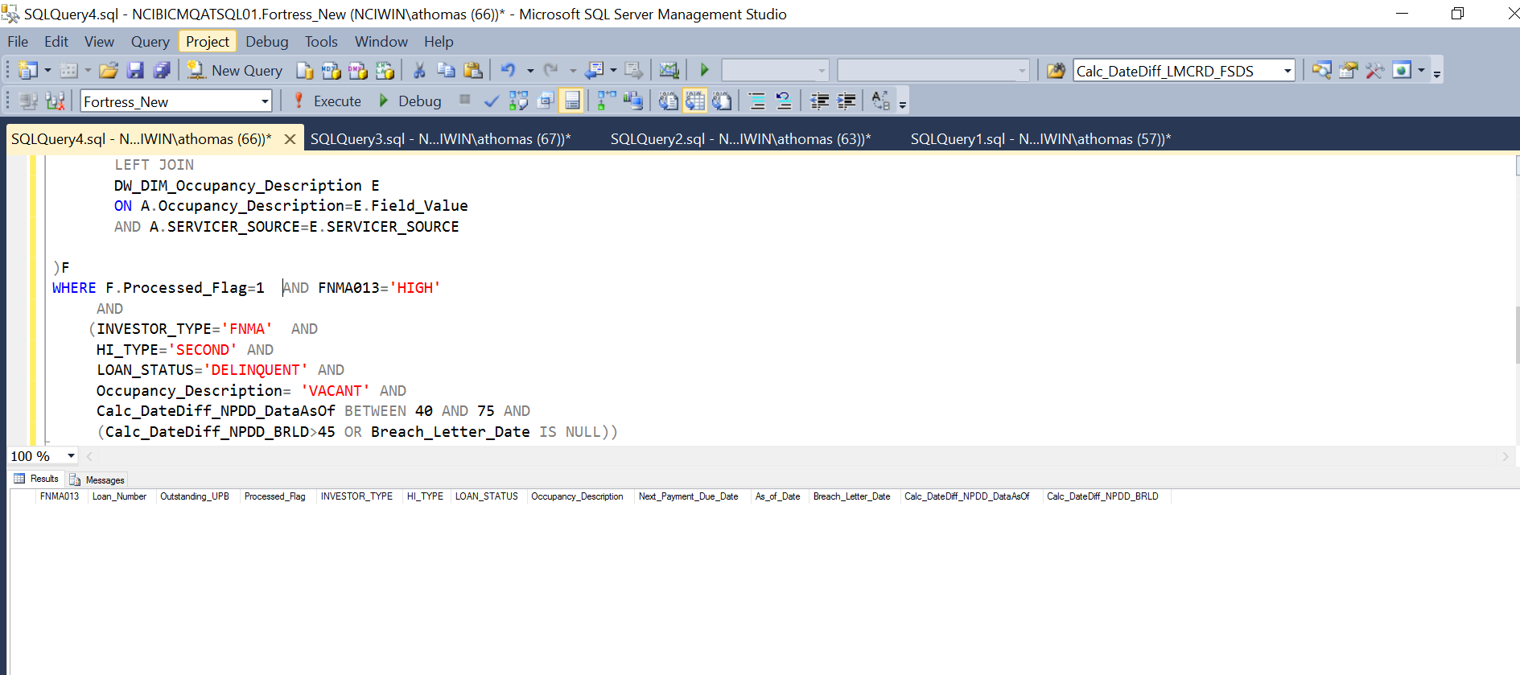

FNMA013<>'HIGH'

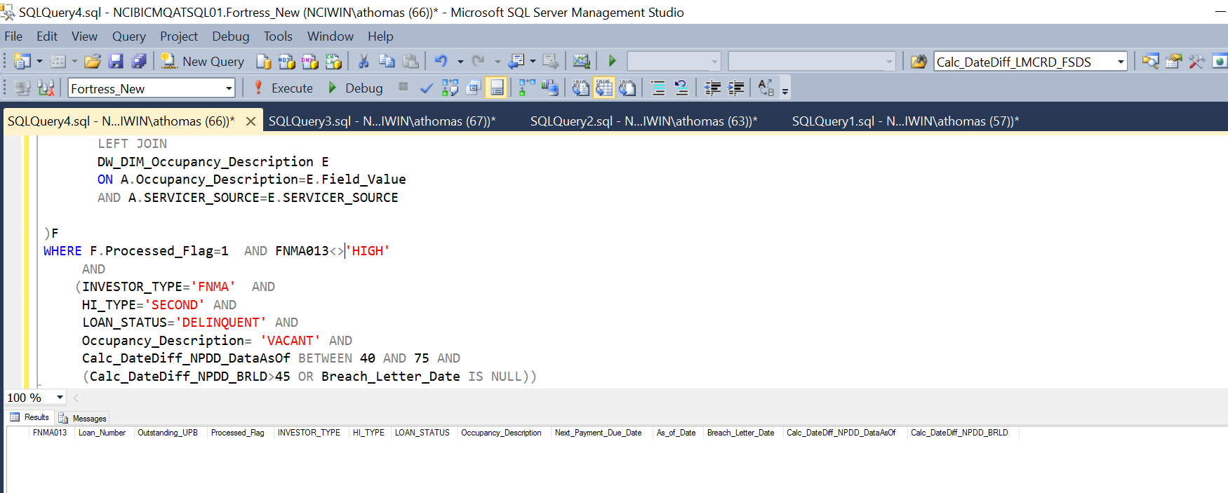

N/A

h. The Investor Type indicates the investor is not FNMA, OR,

i. The HI Type indicates the loan is not a second lien mortgage, OR,

j. The Loan Status indicates the loan is current, OR,

k. The Occupancy Description indicates the property is not abandoned, OR,

l. The Next Payment Due Date is less than 40 or more than 75 days prior to the As of Date of the Servicer File.

SELECT * FROM (Select FNMA013,

A.Loan_Number,

A.Outstanding_UPB,

A.Processed_Flag,

B.FLAG AS INVESTOR_TYPE ,

C.FLAG AS HI_TYPE ,

D.FLAG AS LOAN_STATUS,

E.FLAG AS Occupancy_Description,

A.Next_Payment_Due_Date,A.As_of_Date,

DATEDIFF(D,A.Next_Payment_Due_Date,A.As_of_Date)AS Calc_DateDiff_NPDD_DataAsOf

from

DW_FCT_ALL_SERVICERS_CURRENT A

LEFT JOIN

DW_FCT_FANNIE_MAE_CURRENT_DAY FM

ON A.Loan_Number=FM.Loan_Number

LEFT JOIN

DW_DIM_Investor_Type B

ON A.Investor_Type=B.FIELD_VALUE AND

A.SERVICER_SOURCE=B.SERVICER_SOURCE

LEFT JOIN

DW_DIM_HI_Type C

ON A.HI_Type=C.FIELD_VALUE AND

A.SERVICER_SOURCE=C.SERVICER_SOURCE

LEFT JOIN

DW_DIM_Loan_Status D

ON A.Loan_Status=D.FIELD_VALUE AND

A.SERVICER_SOURCE=D.SERVICER_SOURCE

LEFT JOIN

DW_DIM_Occupancy_Description E

ON A.Occupancy_Description=E.Field_Value

AND A.SERVICER_SOURCE=E.SERVICER_SOURCE

)F

WHERE F.Processed_Flag=1 AND FNMA013='N/A'

AND (

ISNULL(INVESTOR_TYPE,'')<>'FNMA' OR

ISNULL(HI_TYPE,'')<>'SECOND' OR

LOAN_STATUS='CURRENT' OR

ISNULL(Occupancy_Description,'')<>'VACANT'OR

( Calc_DateDiff_NPDD_DataAsOf NOT BETWEEN 40 AND 75 OR Next_Payment_Due_Date IS NULL ))

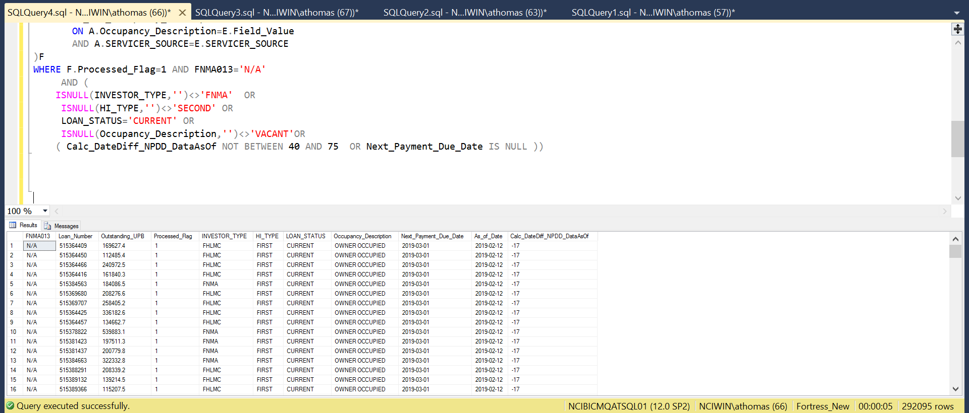

FNMA013<>'N/A'

